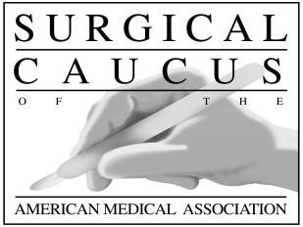

Surgical Caucus of the AMA

2020 Dues Invoice – Delegates/Alternates
$60.00

Charles Drueck, MD, FACS, Treasurer

NAME:
ADDRESS:
CITY, STATE, ZIP:

HOD STATUS: REPRESENTING:

Join your surgeon and specialty colleagues today to support the Surgical Caucus of the AMA! The Caucus meets twice yearly at the AMA House of Delegates, conducting a review of HOD handbook materials and Caucus business (Saturday morning), and sponsoring highly-rated CME sessions at each HOD for a total of 2-3 CME credit hours per year.

To make your payment for 2020 Surgical Caucus dues, send a check for $60, or pay by credit card below. If by check, make it payable to Surgical Caucus of the AMA and mail it with a copy of this entire invoice to: Jon Sutton, Surgical Caucus Administrator, American College of Surgeons, 20 F Street, NW, Suite 1000, Washington, DC 20001.

Paying by credit card? Complete the following and mail this entire invoice to Jon Sutton as listed above, or email to jsutton@facs.org, or fax to Jon Sutton at 202-337-4271.

Please charge my credit card: AMEX _ VISA _ Mastercard _ _ Discover ____

Dues Amount: $60.00

Card Number: Expiration Date: /

Billing Address Zip Code: __ Security Code/CVV:

Print Name as it appears on card:

Signature:

Preferred Email Address: ______________________________________________________

Thanks for your support of the Surgical Caucus!

