Timely Administration post-TURBT (TApT)
Quality Improvement Collaborative Details

Timely administration of IVC post TURBT is a national quality improvement (QI) project sponsored by ACS Cancer Programs beginning February 2026. The project will aid and assist programs in identifying areas for improvement in compliance related to NCDB quality measure BLCT1: For patients with low grade Ta bladder cancer undergoing transurethral resection of bladder tumor, intravesical chemotherapy is initiated within 24 hours of the procedure, or recommended.

The goal of this project is to:
- Improve the quality of cancer care and patient outcomes by accomplishing delivery of intravesical chemotherapy within 24 hours of the procedure
- Assist programs to identify root cause challenges in achieving compliance
- Develop a standardized way for programs to assess and monitor their compliance
- Identify and implement successful and sustainable solutions
- Support participating programs to achieve > a 20% increase of individual baseline

Why is this important?
Bladder cancer is the sixth most diagnosed malignancy, with most patients presenting with non–muscle-invasive disease.1,2 Management of non–muscle-invasive bladder cancer (NMIBC) is challenging due to its high recurrence rates, significant surveillance burden, and potential for progression. Multiple randomized controlled trials have demonstrated the benefits of intravesical chemotherapy (IVC) instillation following transurethral resection of bladder tumor (TURBT). 3-6 Messing et al. reported significantly lower recurrence rates in patients who received postoperative gemcitabine after TURBT for suspected low-grade NMIBC.3
Similar findings have been observed in other RCTs evaluating epirubicin and mitomycin. 4-6 A 2013 meta-analysis reported a 13% reduction in recurrence, while another found that a single postoperative dose of IVC prolonged the recurrence-free interval by 38% and resulted in a 12% reduction in early cancer recurrence.7,8 Given the robust Level 1 evidence supporting the use of single-dose intravesical chemotherapy after TURBT, major cancer care organizations—including the American Urological Association (AUA) and the National Comprehensive Cancer Network (NCCN)—recommend routine postoperative instillation of IVC in appropriately selected patients.9,10

Despite strong evidence and guideline recommendations, compliance rates among urologists remain low, ranging from 0.33% to 28.4%.11-13 The reasons for this low compliance are multifactorial; however, one study identified workflow implementation issues and provider concerns regarding toxicity as key contributing factors.14 Efforts to increase utilization are ongoing, with the American College of Surgeons’ Commission on Cancer (CoC) designating the administration of intravesical chemotherapy after TURBT as a CoC Quality Measure (QM). The establishment of postop chemo after TURBT as a CoC QM presents an opportunity that this activity is now abstracted at all CoC institutions (~70% of cancer care in the US) as part of their required tumor registrar infrastructure and available through NCDB as well as within institutional Cancer Committees.

Who should participate?
Programs interested in improving systems and workflows and want to implement innovative solutions in addressing quality measure BLCT1.
- Programs must have a pharmacy on site or access and ability to provide intravesical chemotherapy instillation with gemcitabine or mitomycin.
- Programs must have completed at least 10 eligible cases for the BLCT1 measure in the 2024 calendar year
- Programs must be willing to abstract a subset of data for patients that meet criteria for this measure into RCRS within three months (90 days).
We strongly recommend you form a core QI team that fulfills the following roles:
- Physician champion: Physician with knowledge of the project that acts as a conduit between the QI team and leadership, urologist, and pharmacy
- Clinician project leader: supports the day-to-day activities of the QI project. Communicates project status with internal and external stakeholders.
- Oncology Data Specialists or similar: a dedicated person to analyze, interpret, and submit data
- Nursing staff member: may provide support pre or post op and understands communication channels
- Pharmacy team member: familiar with chemotherapy drugs used in intravesical administration
*Note: one person may serve in more than one role, but a minimum of 3 people on the core QI team is required.

What will you do?
Step 1: Present project to cancer committee. Receive signature of support from the Cancer Committee and urologist (if available) (template available). Form a core QI team as described above and discuss participation with cancer committee.
Step 2: Conduct a root cause analysis and current state process map. Resources for completing a root cause analysis will be given to all programs.
Step 3: Join group calls to share challenges, innovations, and learn from peers.
Step 4: Submit bladder patients via your cancer registry software to RCRS (or via REDCap). Respond to pre/mid/post questionnaires (sent to Primary contact via REDCap) related to root causes, implementation strategies, and tests of change
DRAFT: SUBJECT TO CHANGE BASED ON TETSING AND FEEDBACK
 | Eligible Patients | Data Due
Baseline | March 1-May 31 2024* | March 30
Collection 2 | March 1-May 31, 2026 | June 30
Collection 3 | June 1-August 31, 2026 | Sept 30
Collection 4 | Sept 1-Nov 2026 | Dec 31
*If all 2024 cases have been sent to RCRS, nothing is needed for this deadline
Step 5: Develop and implement an intervention plan to test improvement in post TURBT IVC compliance. Annotate where/when interventions were implemented and how that impacted program’s compliance
Step 6: Meaningfully participate and engage in the QI project. Over the course of the yearlong QI project, you will be submitting data (see below) and it is strongly recommended you participate in webinars and group calls.

What data will be collected?
This project will use REDCap to collect survey information on root causes, barriers, programmatic resources, implementation interventions, and satisfaction. Programs will also have the opportunity to provide written feedback, or ask questions to be addressed on future calls. These surveys will be sent to the primary contact 30-60 days before they are due. A PDF of the survey will also be attached to the link.
Pre/mid/post survey: Collected via REDCap due April 30, August 31, December 31
This project will also collect patient level data to be abstracted in cancer registry software and sent to RCRS, or to be entered individually into REDCap (if abstraction and RCRS are not an option/not preferable) Patient Measures: Collected Quarterly (March 31, June 30, September 30, and December 3, 2026)
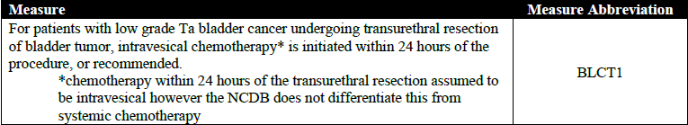
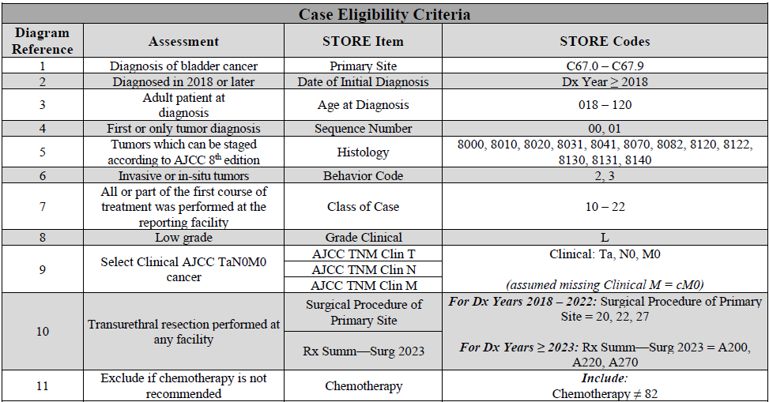

Note: No patient identifying information will be collected.
Note: Please view the FAQ on the project website for questions related to inclusion and exclusion.
FAQ WILL BE UPDATED AND ADDED TO WEBSITE 5-7 DAYS POST INFORMATIONAL WEBINAR

What is the benefit of participating?

- Access to asynchronous learning materials, didactic webinars, and one on one coaching and technical assistance, as needed.
- Data submissions to aggregate and benchmark program progress against aggregate project benchmark
- Collaborate and network with peer programs and national leaders
- Earn credit for CoC standards 7.2, 7.3, (PENDING APPROVAL)
- Improve quality measure BLCT1
- Opportunity to showcase innovations and learnings at future ACS conferences

Timeline and Important dates

Date | Event
November 14, 2025  11am CT | Informational webinar, Intent to participate survey opens (via project website)
Feb 15, 2026 | Intent to participate survey and letter of support due (include hyperlink)
March 13, 2026  11am CT | Collaborative call  Overview of project  The science and evidence behind BLCT1  QI and process mapping, root cause case study
March 31 | Baseline Collection data due (eligible patients March 1-May 31, 2024)
April 30 | Pre-Survey due (sent via REDCap to primary contact)  Letter of Support DUE with first REDCap Survey  Data submission examples and case study videos released
March-May | Programs complete process map, identify root causes
June 30 | Collection 2 data due (eligible patients March 1- May 31 2026)
June-August | Programs develop interventions based on root cause; develop a future state map
August 14, 2026  11am CT | Collaborative call 2
August 31 | Mid Year survey due (sent via REDCap to primary contact)
September 30 | Collection 3 data due (eligible patients June 1-August 31, 2026)
September-November | Programs implement interventions
November 13, 2026 | Collaborative Call 3
December 31 | Collection 4 data due (eligible patients Sept 1-Nov 30, 2026)  Final Survey Due

Optional and as needed “office hours” will be offered

References:
- DeGeorge KC, Holt HR, Hodges SC. Bladder Cancer: Diagnosis and Treatment. Am Fam Physician. 2017 Oct 15;96(8):507-514. PMID: 29094888.
- Tian J, Sun J, Fu G, Xu Z, Chen X, Shi Y, Jin B. Population-based outcome of muscle-invasive bladder cancer following radical cystectomy: who can benefit from adjuvant chemotherapy? Transl Androl Urol. 2021 Jan;10(1):356-373. doi: 10.21037/tau-20-960. PMID: 33532324; PMCID: PMC7844522.
- Messing EM, Tangen CM, Lerner SP, et al. Effect of Intravesical Instillation of Gemcitabine vs Saline Immediately Following Resection of Suspected Low-Grade Non–Muscle-Invasive Bladder Cancer on Tumor Recurrence: SWOG S0337 Randomized Clinical Trial. JAMA : the journal of the American Medical Association. 2018;319(18):1880-1888. doi:10.1001/jama.2018.4657
- Oosterlinck W, Kurth KH, Schröder F, Bultinck J, Hammond B, Sylvester R. A Prospective European Organization for Research and Treatment of Cancer Genitourinary Group Randomized Trial Comparing Transurethral Resection Followed by a Single Intravesical Instillation of Epirubicin or Water in Single Stage Ta, T1 Papillary Carcinoma of the Bladder. Journal of Urology. 1993;149(4):749-752. doi:10.1016/S0022-5347(17)36198-0
- SOLSONA E, IBORRA I, RICOS JV, MONROS JL, CASANOVA J, DUMONT R. EFFECTIVENESS OF A SINGLE IMMEDIATE MITOMYCIN C INSTILLATION IN PATIENTS WITH LOW RISK SUPERFICIAL BLADDER CANCER: SHORT AND LONG-TERM FOLLOWUP. The Journal of urology. 1999;161(4):1120-1123. doi:10.1016/S0022-5347(01)61606-9
- Tolley DA, Parmar MK, Grigor KM, et al. The effect of intravesical mitomycin C on recurrence of newly diagnosed superficial bladder cancer: a further report with 7 years of follow up. The Journal of urology. 1996;155(4):1233-1238.
- Abern MR, Owusu RA, Anderson MR, Rampersaud EN, Inman BA. Perioperative intravesical chemotherapy in non-muscle-invasive bladder cancer: a systematic review and meta-analysis. J Natl Compr Canc Netw. 2013 Apr 1;11(4):477-84. doi: 10.6004/jnccn.2013.0060. PMID: 23584348.
- Perlis N, Zlotta AR, Beyene J, Finelli A, Fleshner NE, Kulkarni GS. Immediate post-transurethral resection of bladder tumor intravesical chemotherapy prevents non-muscle-invasive bladder cancer recurrences: an updated meta-analysis on 2548 patients and quality-of-evidence review. Eur Urol. 2013 Sep;64(3):421-30. doi: 10.1016/j.eururo.2013.06.009. Epub 2013 Jun 19. PMID: 23830475.
- AUA/SUO Guideline: 2024 Amendment. J Urol. 2024 Apr;211(4):533-538.
- Gurski, L. A. (2024). NCCN Guidelines® Insights: Bladder Cancer, Version 3.2024. Journal of the National Comprehensive Cancer Network : JNCCN, 22(4), 216-225.
- Dahmen AS, Nusbaum DJ, Lazarovich A, Fialkoff J, Modi PK, Agarwal PK. Trends in the use of immediate postoperative intravesical chemotherapy following transurethral resection of bladder tumors. Urologic oncology. 2025;43(1):62.e7-62.e13. doi:10.1016/j.urolonc.2024.07.016
- Cookson MS, Chang SS, Oefelein MG, Gallagher JR, Schwartz B, Heap K. National Practice Patterns for Immediate Postoperative Instillation of Chemotherapy in Nonmuscle Invasive Bladder Cancer. The Journal of urology. 2012;187(5):1571-1576. doi:10.1016/j.juro.2011.12.056
- Madeb R, Golijanin D, Noyes K, et al. Treatment of Non-Muscle Invading Bladder Cancer: Do physicians in the United States Practice Evidence Based Medicine? : The use and economic implications of Intravesical Chemotherapy after Transurethral Resection of Bladder Tumors. Cancer. 2009;115(12):2660-2670. doi:10.1002/cncr.24311
- Cary C, Militello L, Weiner M, DeChant P, Frankel R, Koch M. PD32-07 BARRIERS TO SINGLE-DOSE INTRAVESICAL CHEMOTHERAPY IN NON-MUSCLE INVASIVE BLADDER CANCER: WHAT’S THE PROBLEM? The Journal of urology. 2020;203(Supplement 4). doi:10.1097/JU.0000000000000896.07

