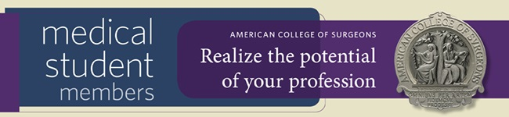

Dear Dr. X,

As the position in chapter representing the name of chapter of the American College of Surgeons (ACS), I would like to encourage you to apply to become a Medical Student Member of the ACS. Membership is only $20 and covers all years of medical school.

Join the more than 3,000 medical students across the country who have turned to the American College of Surgeons (ACS) to learn more about how to prepare for a career in surgery. As a Medical Student Member, you will receive access to a wide variety of benefits to enhance your professional experience and assist you on your path to becoming a surgeon.

In addition to the many benefits outlined in the Medical Student Member brochure, Medical Student Members of the ACS have the opportunity to engage with other surgeons in their community by joining one of the College’s 113 local chapters. At the chapter level, medical students can begin to network and build strong relationships with local surgeons, participate in advocacy and educational activities, take on leadership roles within the chapter, and participate in medical student focused activities.

If you have any questions about the value of ACS membership, or the benefits of joining the chapter name, please do not hesitate to contact me at contact info.

Visit https://www.facs.org/member-services/join/resident and realize the potential of your profession today!

Best regards,

Name
Role in Chapter

