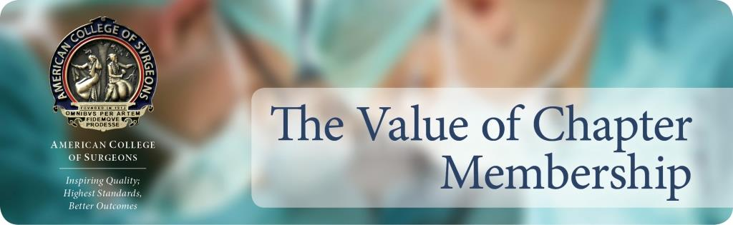

Dear Dr. [insert name]

Congratulations on your acceptance as an Initiate into the American College of Surgeons! The [insert chapter name] is pleased to learn of your upcoming Fellowship, and would like to take this opportunity to inform you of the benefits our local chapter of ACS has to offer:

- Networking: Networking opportunities that enable members to build strong professional relationships with surgical peers
- Advocacy: Opportunities to participate in advocacy activities at the state and federal levels that impact the practicing surgeon and patients
- Continuing education: Convenient educational meetings and local CME
- Leadership opportunities: Leadership opportunities within the chapter council that can translate to future leadership roles within the College
- Volunteerism: Occasions to give back to the profession through volunteerism, both domestically and internationally
- Mentoring: A forum to engage and mentor young surgeons, trainees, and medical students.
- [list any other benefits unique to your chapter]

I would like to formally invite you to become a member of the [insert chapter name] and offer you [insert membership discount offer] during your first year as a Fellow with the American College of Surgeons. Visit the [insert chapter website URL] to learn more about what the [insert chapter name] can do to enhance your membership in the American College of Surgeons.

Sincerely,

President of the [insert chapter name]

