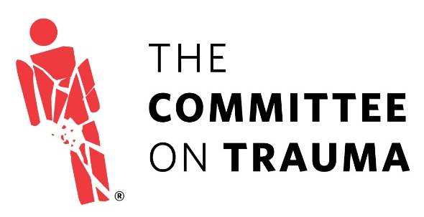

American College of Surgeons
Committee on Trauma

FUTURE TRAUMA LEADERS APPLICATION FORM

PERSONAL INFORMATION | YOUR ANSWERS
First & Last Name:
Institution Name:
Address:
Title/Position:
Specialty:
Email:
Phone:
Years in Practice (Post Fellowship):

Participant Attachments/Uploads:
□ Current CV
□ 2 Letters of Recommendation (one MUST be from your Division/Program Chief and must note his/her support for the time away from clinical work for these activities)
□ Essay on why you would like to participate in this program and what you hope to gain from participation
(essay should be no longer than ONE page)

GENERAL QUESTIONS | YOUR ANSWERS
Are you a Fellow of the American College of Surgeons? | □ ACS Fellow □ ACS Associate Fellow
Are you active-duty military? | □ No □ Yes Branch:
If active-duty, length of service commitment?
Is your practice university based, private, or group? | □ University □ Private □ Group
Are you currently active in the field of trauma?
(please describe)
What percentage of your current professional activities involves the care of the injured patient?
Have you been involved with the ACS State or Provincial Trauma Committee in your area?
(please describe)
Please describe any prior involvement with the Resident and Associate Society (RAS-ACS):
Please describe any prior or current involvement with the Young Fellows Association (YFA):

COT PROJECT AREAS

Please rank your areas of interest and any special skills/accomplishment you would bring to the following:
Rank
Advocacy
Disaster Preparedness
Education
Emergency Medical Services
Injury Prevention
Performance Improvement/Guideline Development
Quality & Data Measurements
Rural Trauma
Trauma Center Evaluation
Trauma Systems Consultation

PARTICIPATION IN COT ACTIVITIES
Have you taken the ATLS® Provider course? □ Yes □ No
Have you taken the ATLS® Instructor course? □ Yes □ No
If yes, how often do you teach ATLS®?

Are you an ATLS® Course Director? □ Yes □ No
If yes, how often do you direct an ATLS® course?

Does your hospital submit data to NTDB®? □ Yes □ No
If so, how have you used NTDB data in your own research or to evaluate your hospital’s performance?

Does your hospital participate in the ACS Trauma Quality Improvement Project (TQIP)? □ Yes □ No
Is your hospital verified by ACS? □ Yes □ No If so, at what Level?

For the following, please select all that apply:
TOPIC course □ Course Taken □ Course Instructor
Rural Trauma Team Development course □ Course Taken □ Course Instructor
Disaster Management & Preparedness course □ Course Taken □ Course Instructor
Are you a member of any of the following Associations?
□ American Association for the Surgery of Trauma □ EAST □ WEST
Are you willing to attend the COT Annual Meeting each spring and the committee meetings held in conjunction with the Clinical Congress each fall, the Annual TQIP meeting and the Annual ACS Advocacy meeting?
□ Yes □ No

Jené Hickman
Trauma Office - American College of Surgeons
(312) 212-5661 jhickman@facs.org

