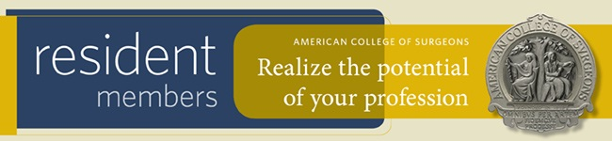

Dear Dr. X,

As the position in chapter representing the name of chapter of the American College of Surgeons (ACS), I would like to encourage you to apply to become a Resident Member of the ACS.

Joining the College as a Resident Member represents an important milestone in your surgical career, and signifies your personal commitment to furthering your professional development and conducting your surgical career with the highest set of professional standards. The ACS is here to support you on your path to ACS Fellowship.

Resident membership is available to surgical residents who are currently enrolled in an accredited training program focused on one of the 13 surgical specialties, as well as those who have completed an initial residency and are currently involved in surgical research or a surgical fellowship.

In addition to the many benefits outlined in the Resident Member brochure, Resident Members of the ACS have the opportunity to engage with other surgeons in their community by joining one of the College’s 113 local chapters. At the chapter level, Resident Members can network and build strong relationships with local surgeons, participate in advocacy and educational activities, take on leadership roles, and participate in resident focused activities such Surgical Jeopardy, Surgical Skills competitions, and poster/paper competitions.

If you have any questions about the value of ACS membership, or the benefits of joining the chapter name, please do not hesitate to contact me at contact info.

Visit https://www.facs.org/member-services/join/resident and realize the potential of your profession today!

Best regards,

Name
Role in Chapter

