TQIP Collaborative Drilldown Exercise

*Note: Items highlighted in yellow should be completed by the Collaborative Leader before distributing to centers. After distribution, items highlighted in green should be completed by the centers and sent back to the Collaborative Leader.

Your Collaborative has been identified as a [low; high] outlier for the following outcome in the following cohort, as presented in the [Fall 2020 Adult TQIP Benchmark Report]:
[Outcome] in the [Cohort] cohort (e.g. Mortality in the sTBI cohort)

As a result, we are asking that all of our participating centers complete the following worksheet to help identify potential causes for this status. When completed, or if you have any questions regarding this process, please email XX who will be responsible for aggregating the information into a summary report.

A | TQIP Report ID: | [1-4 digit #]
B | What is your hospital’s outlier status for the model as indicated above?  This can be found in the Outlier column of the Risk-Adjusted [Outcome] by Cohort table for the selected outcome and selected cohort. | [Non-outlier, High, Low]
C | How many patients met cohort criteria for the model as indicated above?  This can be found in the N column of the Risk-Adjusted [Outcome] by Cohort table for the selected outcome and selected cohort. | [N]
D | How many of your patients in row C had an adverse outcome occur? [E.g. number of patients in the sTBI cohort who died].  This can be found in the Observed Events column of the Risk-Adjusted [Outcome] by Cohort table for the selected outcome and selected cohort. | [N]
E | How many of your patients in row C had a favorable outcome? [E.g. number of patients in the sTBI cohort who lived].  This can be found by subtracting the count from row D above from the count in row C above. | [N]

For the following information, you will be required to access the TQIP Data Download Report (DDR). You can access that application by logging into the TQP Data Center. On the initial screen, you will see an option for Operational Reports on the left-hand toolbar. Please click that link and then navigate to the link for the Data Download Report, as shown below:

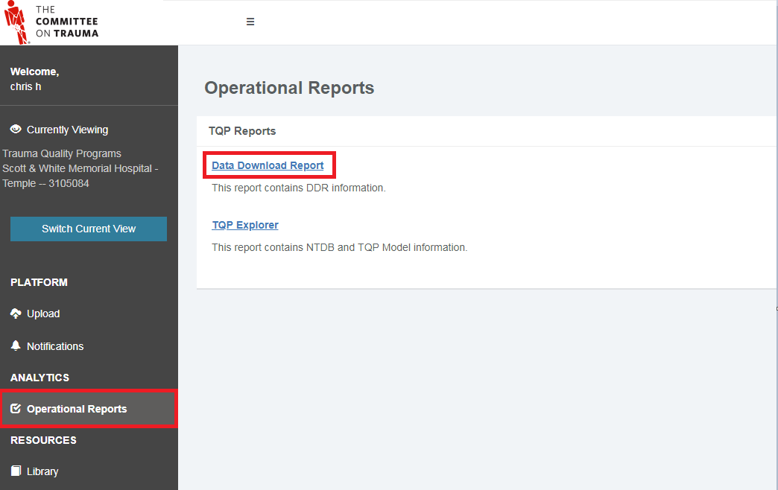

Once inside the application, select the TQIP Data Set and Reporting Period which are appropriate for this exercise [E.g. Adult, Fall 2020]. After the results populate, navigate to the Risk-Adjusted Patient Results tab. You will use this tab, and the following filters, to find the record-level information required for the table below.

- On the filters panel on the left-hand side, collapse the filter groups until you see Risk-Adjusted Patient Results. These filters now match the columns on your screen.
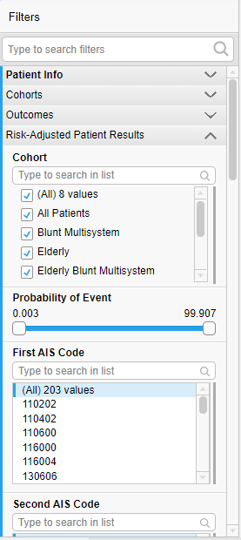

- Select the Outcome and Cohort which match the model selected for this exercise. This will now limit the records on your screen to only those eligible for this model.

- To complete the following tables, you will also need to use the Probability of Event and Event Indicator filters.

F | How many of your patients in row D also had a probability of outcome < .20? (E.g. how many sTBI deaths had a probability of death in the sTBI cohort of less than .20?).  To complete this task, select “Yes” from the Event Indicator filter, and limit the high-end of the Probability of Event filter to ~.2. | [N]
G | Of the patients in row F, how many may have had an unexpected adverse outcome due to issues with data quality?  This could encompass inappropriate mapping or coding with respect to fields considered in the model. The record-level information used in our models can be identified on the Patient Info, Pre-existing Conditions, Hospital Events, and AIS Diagnoses tabs of this tool. The filters you selected will persist across tabs. | [N]
H | What were the most common data quality problems you found for the patients in row G?
I | [Text]
J | Of the patients in row F, how many had an unexpected adverse outcome due to opportunities for improvement with care? | [N]
K | What were the most common clinical care opportunities for improvement you found for the patients in row J?
L | [Text]

Now that you have reviewed those patients who had an unexpected adverse outcome (e.g. unexpected death), you will next review patients who had an unexpected favorable outcome (e.g. unexpected survivor).

M | How many of your patients in row E (those with a favorable outcome) had a probability of adverse outcome > .80? (E.g. what percent of sTBI survivors had a probability of death in the sTBI cohort of greater than .8?)  To complete this task, select “No” from the Event Indicator filter, and limit the low-end of the Probability of Event filter to ~.8. | [N]
N | Of the patients in row M, how many may have had an unexpected favorable outcome due to issues with data quality?  This could encompass inappropriate mapping or coding with respect to fields considered in the model. The record-level information used in our models can be identified on the Patient Info, Pre-existing Conditions, Hospital Events, and AIS Diagnoses tabs of this tool. The filters you selected will persist across tabs. | [N]
O | What were the most common data quality problems you found for the patients in row N?
P | [Text]
Q | Of the patients in row M, how many may have had an unexpected favorable outcome due to exceptional clinical care? | [N]
R | What were the most common exceptional clinical care practices you found for the patients in row Q?
S | [Text]

